International Islamic University Chittagong


Department of Computer Science and Engineering

Project Report on

HTML Online Editor

COURSE CODE | : CSE-3528
COURSE TITLE | : | Compiler lab

Submitted by:

Sadia Moontahin(C201257)

Afsana Mahmuda Timu(C193262)

Nusrat Jahan(C201261)

Tahura Tasmin Chowdhury(C201272)

Sadia Binte Noor(C201259)

Submitted to:

Mrs.Israt Binteh Habib

Lecturer,

Dept. of CSE, IIUC

INTRODUCTION:

Online HTML Editor is a simple project developed using HTML, CSS, and JavaScript. When we open the project, we can see the editor page on browser where we can type code on one side of the page. Also, see its results on another side at the same time. Here, we can only see the content that we write inside the body tag. While the codes inside other tags is not seen but it helps in making some changes to the body content.

PROBLEM STATEMENT:

- How we can edit html page

- How we can see 2 page automatically left side and right side

METHOD:

The Online HTML Editor is simply in HTML5, CSS, canvas, and JavaScript. Taking about the features of this project, there is two division of the editor page. The user can type any code on the left side of the editor page and we can automatically see the changes on the right side of the editor page. Also, we can make changes on the left side of the page and see its result on the right side immediately after the changes.This project includes a lot of javascript for making validations to certain parts of the project.

System Design:

Text Editor

Run code
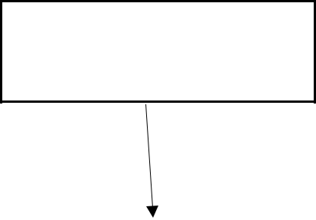

Compiler

Display Result

Output

Figure: Shows a simplified bock diagram of the system design
Implementation :

Language used for implementation:

- HTML

- CSS

- JAVASCRIPT

HTML & CSS are used for design the website (frontend).

JavaScript used to run functions in order to make website more interactive.

To compile the languages of HTML , separate files are created to link to the Visual studio code .exe to which the written code in the text editor is passed to the application in order to run and compile code
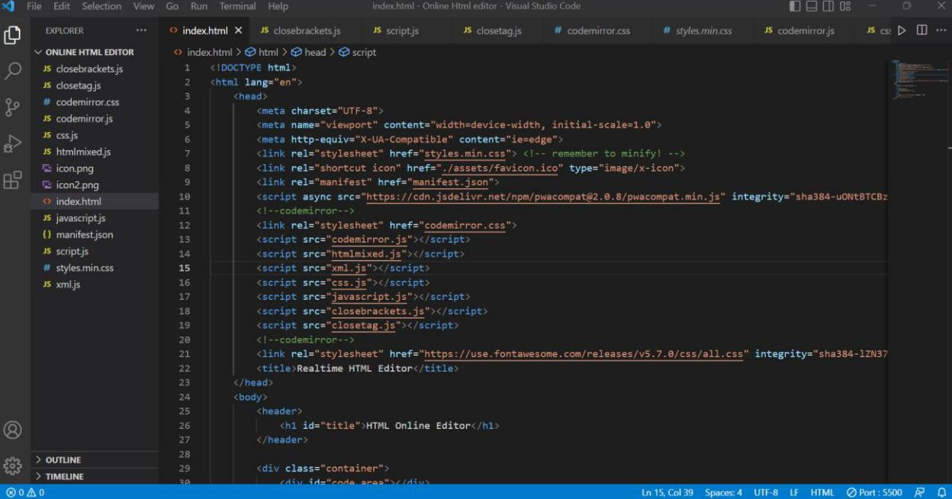

Figure: Shows a part of the code, putting environment of the language file of HTML to the Visual studio code.
Code link: https://code-projects.org/online-html-editor-with-source-code/

RESULT:
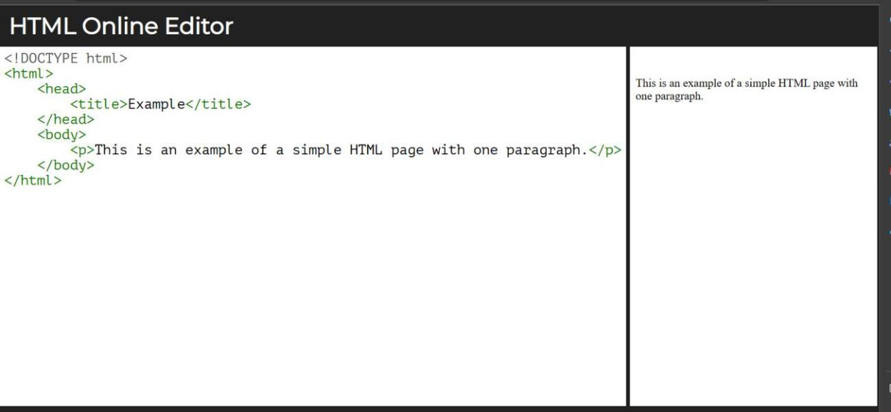

CONCLUSION:

We saw in the Task to be Solved section, that the purpose of an HTML editor is to make producing attractive, informative web pages as easy as possible, and limit the amount of html programming needed to a minimum. We then summarized the features of the four editors in our comparison matrix, and gave an in depth review of each individual editor.

